THE EVOLUTION OF AMPHIBIANS: THE CONQUEST OF THE LAND
Amphibians were the first group of vertebrates to develop limbs and to be able to leave the water to conquer the land. Even if they are seen as simple and primitive animals by most people, amphibians show a wide diversity of survival strategies which have allowed them to occupy most terrestrial and fresh-water habitats. On this entry we’ll explain some of the aspects related to their evolution, explaining how our ancestors managed to get out of the water.

ORIGIN OF THE AMPHIBIANS
Current amphibians, together with reptiles, birds and mammals are found within the superclass Tetrapoda (“four limbs”), the vertebrate group that abandoned the sea to conquer the land. These first tetrapods were amphibians and they evolved around 395 million years ago during the Devonian period from lobe-finned fish named sarcopterygians (class Sarcopterygii, “flesh fins”) within which we find the coelacanth and the current lungfish.
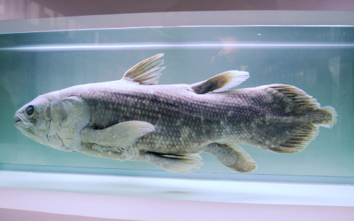
Specimen of coelacanth (Latimeria chalumnae) a sarcopterygian fish, photo by smerikal.
This group of fish is characterized by its fins which, instead of being formed by rays like in most bony fish, they have a bony base that allowed the subsequent evolution of the limbs of the first amphibians. Within the sarcopterygians, the nearest relatives of the tetrapods are the osteolepiformes (order Osteolepiformes) a group of tetrapodomorph fish that got extinct about 299 million years ago.
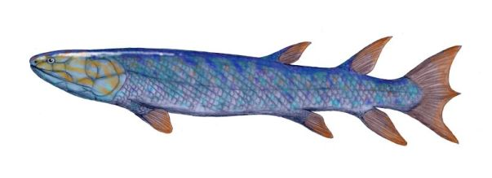Restoration of Eusthenopteron, an extinct osteolepiform, by Nobu Tamura.

ADAPTATIONS TO LIVE ON LAND
The conquest of land was not done from one day to the other; it was possible with the combination of multiple adaptations. Some of the most important characteristics that allowed the first amphibians to leave the water were:
- Evolution of lungs, which are homologous to the gas bladder that allows fish to control its buoyancy. Lungs appeared as an additional way to get oxygen from the air. In fact, there is actually a sarcopterygian family the members of which have lungs to get oxygen from the air, for they live in waters poor on oxygen.
- 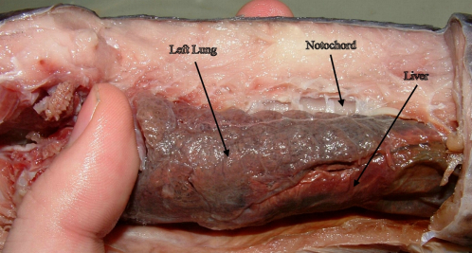Dissection of Protopterus dolloi a sarcopteryigian fish with lungs.
- Development of the choanaes, or internal nostrils. While fish present a pair of external nostrils at each side of its snout through which water passes on while swimming, the ancestors of the tetrapods only had one external nostril at each side connected to the internal nostrils, the choanae, which communicated with the mouth. This allowed them to get air through their noses using lung ventilation and this way to smell outside of water.
- Apparition of the quiridium-like limb. The quiridium is the tetrapod’s most basic characteristic. This limb is known for having the differentiated parts: the stylopodium (one bone, the humerus or the femur), the zeugopodium (two bones, the radius or tibia and ulna or fibula) and the autopodium (fingers, hands, toes and feet). While the stylopodium and zeugopodium derived from the sarcopterygian’s fins, the autopodium is a newly-evolved structure exclusive from tetrapods.
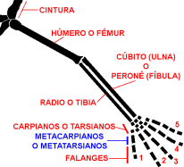
Simplified drawing of the structure of the quiridium, by Francisco Collantes.
In short, the relatives of the osteolepiformes developed the tetrapod’s typical characteristics before ever leaving water, because they probably lived in brackish, shallow waters, poor in oxygen and that dried out quickly and often.

THE FIRST AMPHIBIANS
Probably the creature known as Tiktaalik is the closest animal to the mid-point between the osteolepiformes and the amphibians. The first recorded amphibians were labyrinthodonts meaning that their teeth had layers of dentin and enamel forming a structure similar to a maze.
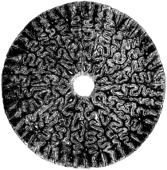Cross-section of a labyrinthodont tooth, form "On the Genesis of Species", by St. George Mivart.
There were four main groups of primitive amphibians, each characterized by: a group that includes the first animals that were able to get out of water, a second group which contains the ancestors of the amniotes (reptiles, birds and mammals) and two more groups, both candidates to be the ancestors of modern amphibians.

Order Ichthyostegalia
Ichthyostegalians were the first tetrapods to be able to leave the water. They appeared at the late Devonian period and they were big animals with large wide heads, short legs and an aquatic or semi aquatic lifestyle (they probably were pretty clumsy on land). They moved around using mainly their muscular tail with rays similar to that of fish.
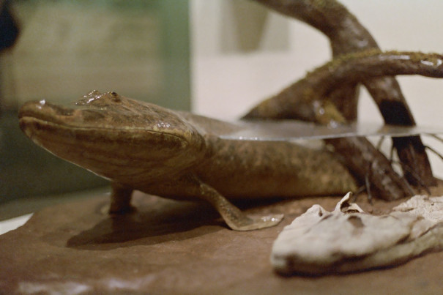Fossil and restoration of Tiktaalik. Photo by Linden Tea.
Similarly to current amphibians, they presented a lateral line (sensory organ that allows fish to detect vibrations and movement underwater) and were able to breathe through their skin (they lost the cosmoid scales of their ancestors). Also, the eggs were laid in the water, from which the tadpoles emerged and later on, they suffered a metamorphosis process to become adults just like current amphibians. Subsequently ichthyostegalians gave rise to the rest of amphibian groups.
Skeletons of Ichthyostega and Acanthostega, two typical ichthyostegalians.

Clade Reptiliomorpha
Reptiliomorphs were the ancestors of amniotes and appeared about 340 million years ago. Most of them were usually large and heavy animals, which presented more advanced adaptations to live on land (laterally-placed eyes instead of dorsally-placed ones and a knobby more impervious skin). Even though, reptiliomorphs still laid their eggs in the water and had larval-stages with gills. It wouldn’t be until the late Carboniferous period when the first amniotes (animals that could lay their eggs on dry land) would emancipate completely from water.
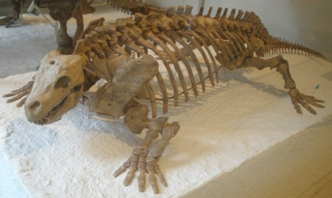Mounted skeleton of Diadectes a large herbivorous reptiliomorph from the American Museum of Natural History, photo by Ghedoghedo.

Order Temnospondyli
This group is one of the possible candidates to being the ancestors of modern amphibians. This is the most diverse group of primitive amphibians and it survived until the early Cretaceous period, about 120 million years ago. The temnospondyls varied greatly in shape, size and lifestyle.
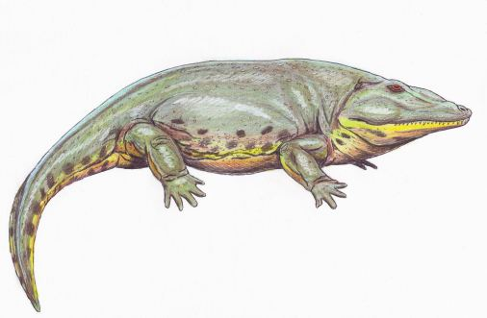Restoration of Eryops megacephalus a large temnospondylian predator, by Dmitry Bogdanov.
Most of them were meat-eaters, but some were terrestrial predators, some were semi aquatic and some had returned completely to water. Even though, all species had to return to water to breed for the fertilization was external; while the female was laying clutches of eggs in the water, the male released the sperm over them.
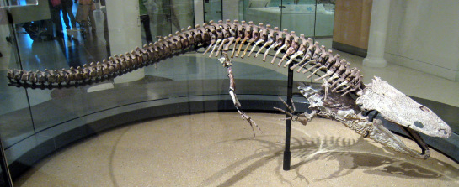
Mounted skeleton of Koskinonodon a 3 metres long temnospondyl, from the American Museum of Natural History, photo by Lawrence.
Within the temnospondyls we can find some of the biggest amphibians that ever lived, such as Prionosuchus, with an estimated length of 4,5 meters and about 300 kilograms of weight. Also, even though their skin was not covered with scales, it wasn’t completely smooth like in modern amphibians.
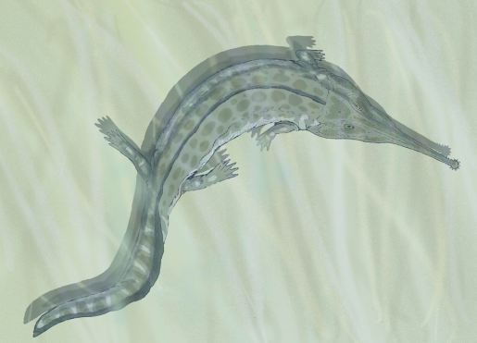Restoration of Prionosuchus by Dmitry Bogdanov.
It is believed that this group could be the sister-taxon of modern amphibians, even though there’s one last group which could be a candidate to that post.

Order Lepospondyli
Lepospondyls were a small group of primitive animals which appeared at the early Carboniferous and disappeared at the late Permian period. Even though lepospondyls were not as numerous and smaller than the temnospondyls, they presented a wide range of body shapes and adaptations.
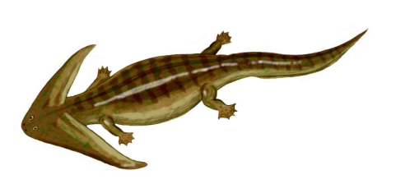Restoration of Diplocaulus magnicornis, of about 1 metre long was the biggest of all lepospondyls, by Nobu Tamura.
The first lepospondyls looked superficially like small lizards, but subsequently lots of groups suffered processes of limb reduction or loss.
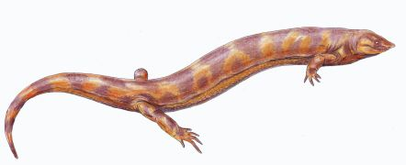Restoration of Pelodosotis, an advanced lepospondyl, by Dmitry Bogdanov.
The relationship of the lepospondyls with the rest of tetrapods isn’t very clear. Different hypothesis go from some authors arguing that they are a group separated from the labyrinthodonts, some thinking that they are the ancestor of current amphibians and reptiles, and some even saying that they are the ancestors of only a portion of modern amphibians.
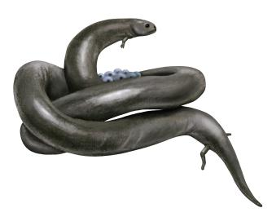Restoration of Lysorophus, a Permian lepospondyl, by Smokeybjb.
As we can see, the classification of primitive amphibians can be an extremely complex thing. On this entry I tried to make a summary of the most important groups of ancient amphibians and, on the next one, we’ll center on the evolution of modern amphibians, the so-called “lissamphibians”, and we’ll look in more detail all the controversies surrounding these curious animals.

